Oliver Twist – A reflection test Name: ______________

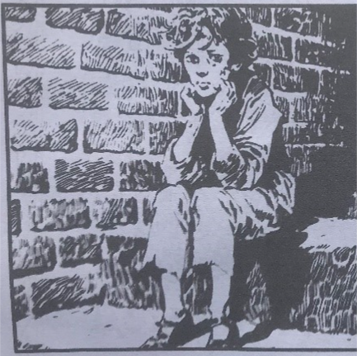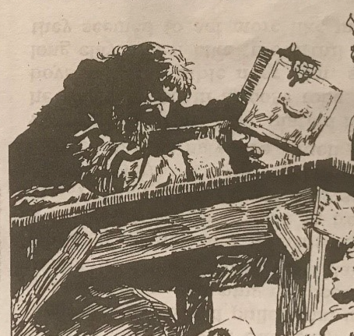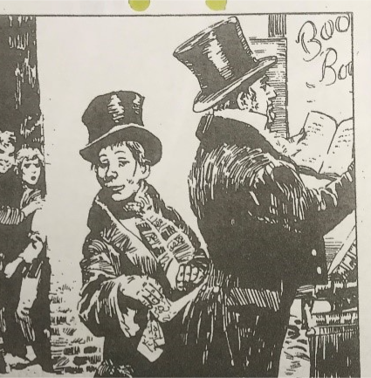

Choose two of the pictures and write what you see and what is going on.
Picture:

Picture:

Who is Oliver? _________________________________________________
______________________________________________________________

Who is Mr. Sowerberry? _________________________________________
______________________________________________________________

Who is Fagin? __________________________________________________
______________________________________________________________
Who is Jack, “The Artful Dodger”? ___________________________________
______________________________________________________________

Who is Mr. Brownlow? ____________________________________________
______________________________________________________________

Who is Nancy? _________________________________________________
______________________________________________________________

Translate:

fattighus | fult ansikte | tjuv
föräldralös | smeknamn | en kall fängelsecell
hungrig | en konstig lek | framför
kistmakare | inomhus | en lång resa
näsduk | domstol | eldstad
en belöning | dränka hunden | en tung låda

Add your own reflections and thoughts. What do you think about the book, or the movie? What do you like or dislike? Explain why!

