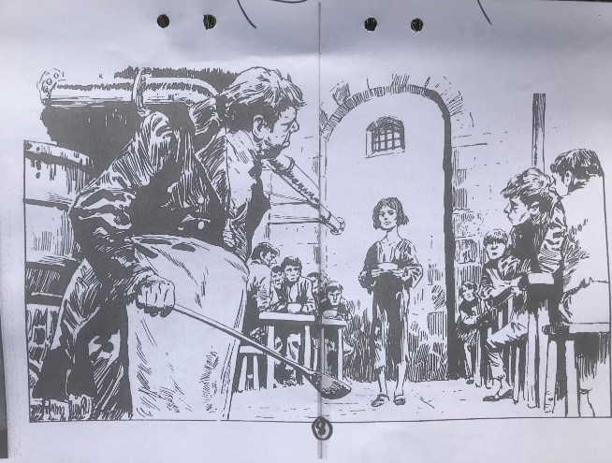
OLIVER TWIST Chapter 1
Before reading:
1.) What is a Workhouse?
2.)Who is Oliver Twist?
After reading:
3.) What do we know about Oliver’s mother and father?
4.) What is a farmhouse?
5.) Who is Mrs. Mann? What do we know about her?
6.) Who is Mr. Bumble? What do we know about him?
7.) How did Oliver Twist get his name?
8.) What is a board? And what does the board do, in this story?
9.) What is an orphan?
10.) What is Oliver doing at work?
11.) What are Oliver and the boys eating at the workhouse?
12.) Why does the kitchen master get angry?
13.) What is the 5 Pound reward about?

Words (on Quizlet):
workhouse | poor people | tiresome
frail | shriveled | thin
faint | pale | feebly
barely | forehead | she gazed around
shuddered | prepared | worn to pieces
nobody knows | sighed | muttered
a wistful look | mean and stingy | crib
complain | punishment | coal cellar
wander away | proper | replied meekly
a small parlor | with a glint in her eye | a reward
fetch him | struggle | members of the board
one gentleman | sternly | frightend
rapped him with a stick | hold back his tears | a fool
you are an orphan | hard and narrow beds | sobbed himself to sleep
hungry and miserable | make life unpleasant | half as much food
taking apart old ropes | stuff the cracks in ships | water-tight
three bowls of thin gruel | supper | a bundle of straws
an enormous iron pot | frozen with fear | blinking in disbelief
hit with his ladle | escape | a sign
the parish | a prisoner | protect
made him feel less lonely | shoved under a pump

OLIVER TWIST Chapter 2
Before reading:
1.) What is a chimney sweep?
2.)What is a judge??
After reading:
3.) What is the judge asking the chimney sweep?
4.) What did Oliver say to the judge?
5.) Who is Mr. Sowerberry?
6.) Where in the shop is Oliver sleeping?
7.) What is a coffin?
8.) Who is Noah Claypole?
9.) Why is Oliver knocking Noah down?
10.) Why did Oliver leave the shop and
Mr. Sowerberry?

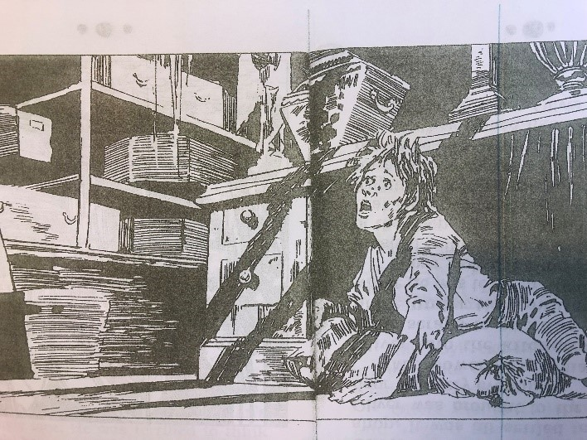
Words (on Quizlet):
a sign | black soot | a donkey
a chimney sweep | landlord | stumble
in front of | muttering curses | he caught sight of
scratched his stubby face | nod | smothered to death by smoke
never mind | a good trade | later in court
teach him a trade | stared in horror | cruel and ugly face
wide-eyed with fear | exclaimed the judge | what is the matter
clasped his hands together | he would rather go back | I refuse
treat him more kindly | an under-taker | measure
coffin-maker | a nasty wife | some scraps to eat
a counter in the shop | it was so gloomy in the room | creature
walk towards him | row of square-shouldered ghosts | you little workhouse brat
get that broom | the look of sadness | take part in the funerals
on many occasions | very jealous | he was enraged
the insult | made him with fierce | astonishment
perhaps he is mad | over-fed | he has spirit
humble and meek | generous | defend himself
whip the boy | starve him | in a handkerchief
rays of light

OLIVER TWIST Chapter 3
Before reading:
1.) What do you know about London?
.
2.) How long is a mile?
After reading:
3.) How did Oliver survive this long walk?
. . .
4.) Who is “the artful Dodger”? And what is so special about him?
.
5.) Who is Fagin?
.
6.) What is going on in this room where Fagin lives?
.
7.) Fagin has a heavy box – with what?
.
8.) What are Charley and the other boys doing
for work?
.
9.) Fagin and his boys are playing a strange game?
What?

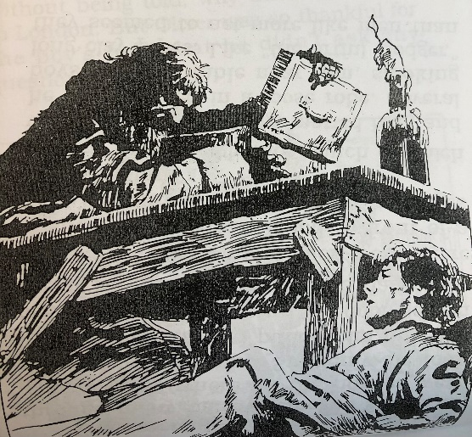

Words (on Quizlet):
mile | stone marker | bold letters
big arrow | a huge city | a lad
make a living | determined to try | a steep hill
a stagecoach | beg for help | sore feet
a lazy fool | threatened to set his dog on him | limped slowly
covered with dust | loneliness | an odd-looking boy
behave like an old man | a top hat and a coat | the artful dodger
nickname | many narrow crooked streets | a broken stairway
toasting sausages on a long fork | an ugly face | dressed in a loose robe
smoking long clay pipes | my new pal | countless silk handkerchiefs
hung on a wooden rack | stare | a hot drink
drowsy | a trap door | a heavy box
he raised the lid | a splendid gold watch | jewels
bracelets | he had been joking | a brave boy
a pitcher of water | two leather wallets | a strange game
trousers | a long chain | a little pocket
pretending that he was rich | fireplace | he slapped his pockets

